RH047: Quick-Fusion Cloning with VDB#1009-SAdCas9-BFP-hTdT 3/3/16 11:00 AM

PURPOSE:
To delete 36bp of unneeded sequence from VDB#1009-SAdCas9-BFP-hTdT
MATERIALS:
- Template DNA (VDB#1009_sEF1a-Puro-T2A-BFP-P2A-SAdCas9-hTdT-3xHA)
- NEB PshAI Restriction Endonuclease [Cat#R0593S]
- NEB BlpI Restriction Endonuclease [Cat#R0585S]
- NEB CutSmart Buffer [Cat#B7204S]
- MacheryNagel PCR and Gel Purification Kit [Cat#740.609.250]
- IDT oligo FOR-BFP: GGAGGCCAACAACGAGACC
- IDT oligo FOR-SV40NLS-SAdCas9: CCAAAGAAGAAGCGGAAGGTCAAGCGGAACTACATCCTGGG
- IDT oligo REV-P2A-SV40NLS: GACCTTCCGCTTCTTCTTTGGTCCTGGGTTTTCTTCCACGTCC
- IDT oligo REV-SAdCas9: AGAGAACTCTTCCTCGCTCAGC
- Bio-Rad T100 Thermal Cycler PCR machine, PCR tubes, pipettes
- Thermo Scientific Phusion Hot Start High-Fidelity DNA Polymerase [#F-540L; Lot#00266599]
- Thermo Scientific Phusion 5X HF Buffer [#F-540L; Lot#00266599]
- Invitrogen 10mM dNTPs [Cat#18427-013; Lot#1718532]
- BioTools QuickFusion Fusion Enzyme [Cat#B22611]
- BioTools QuickFusion 5X Fusion Buffer [Cat#B22611]
- Chemically competent DH5alpha E. Coli cells [Elizabeth J Cahill]
- LB-Amp 100ug/mL agar plates [Cat#L1004; Lot#L100406K1501]
- 1000X Ampicilin 100mg/mL
- LB Ampicillin 100ug/mL Broth
- QiAprep Spin Miniprep Kit (250) [Cat#27106; Lot#151030258]
- QB4442 MGTT-F1 forward seq primer: TCCAACGGCCCTGTGATGC
- IDT seq primer FOR-SAdCas9 (#2): GGCGGAGGCGGCATA
- IDT seq primer REV-SAdCas9 (#4): CGCCTGCCCTCGTTG
- IDT seq primer REV-SAdCas9 (#3): CCAGGGCCTTGCTGTTCC

METHOD:
PshAI and BlpI Double Digest VDB#1009
- 12uL 340ng/uL 4ug DNA, 16uL 10X NEB CutSmart, 8uL PshAI, 8uL BlpI, 116uL ddH₂O, 160uL total
- Incubated double digests at 37°C for 60min
PCR Amplify 175bp and 336bp PCR products
- PCR tube: 1uL 10mM dNTPs, 0.5uL 100uM F-primer, 0.5uL 10uM R-primer, 0.5uL VDB#1009,
10uL 5X HF Buffer, 0.5uL 2U/uL Phusion polymerase, 37uL ddH₂O, 50uL total volume
- PCR tube: 1uL 10mM dNTPs, 0.5uL 100uM F-primer, 0.5uL 10uM R-primer, 0.5uL VDB#1009,
10uL 5X HF Buffer, 0.5uL 2U/uL Phusion polymerase, 37uL ddH₂O, 50uL total volume
- PCR cycling parameters: initial denaturation 98°C 30sec, denaturation 98°C 10sec, annealing 55°C 20sec, extension 72°C 15sec, final extension 72°C 2min, amplify 40 cycles, 4°C hold indefinitely
Gel Extract and Purify 11,932bp Backbone and 175/336bp PCR product
- Entire volume of rxn into 2.5% (PCR) agarose gel at 120V for ~60min
- Entire volume of rxn into 0.65% (backbone) agarose gel at 100V for ~200min
- Liquefied gel: 300uL NTI per 150mg gel and incubated 50°C 10-20min
- Bound column: entire volume to spin column and centrifuged 11000g 30sec
- Washed column: 700uL NT3, centrifuged 11000g 30sec, discarded flow-through, repeated 3x
- Dried silica membrane: centrifuged 11000g 30sec, transferred column to new microfuge tube
- Eluted DNA: 30uL NE, centrifuged 11000g 30sec
- Nanodropped eluates and recorded concentrations as 112ng/uL (175bp) and 40ng/uL (336bp)
- C1V1 to determine volume ddH₂O to add such that final concentration is ~6ng/uL
Quick-Fusion Cloning
- Aimed for ideal molar ratio of 2:1 for insert to linearized backbone
- PCR tube#1: 2.34uL 41ng/uL 95.85ng 13fmol backbone, 0.38uL 7.4ng/uL 2.8ng 26fmol 175bp insert, 1.04uL 5.6ng/uL 5.4ng 26fmol 336bp insert, 2uL 5X Fusion Buffer, 1uL Fusion Enzyme, 3.24uL ddH₂O, incubated 37°C 30min
- PCR tube#2: 1.74uL 55ng/uL 95.85ng 13fmol backbone, 0.38uL 7.4ng/uL 2.8ng 26fmol 175bp insert, 0.83uL 6.5ng/uL 5.4ng 26fmol 336bp insert, 2uL 5X Fusion Buffer, 1uL Fusion Enzyme, 4.05uL ddH₂O, incubated 37°C 30min
Transformation and Plating
- Transformation: 50uL DH5alpha E.coli, 2uL DNA, iced 20min, heat shocked 42°C 2min, iced 2min
- LB-Amp plated 50uL transformed cells and incubated 37°C ~16hrs
Mini-Prep Quick-Fusion Products
- Picked 8 colonies to inoculate in 6mL of LB-Amp100 broth
- Incubated bacterial culture: Placed on 225rpm shaker at 37°C for ~18hrs
- Pelleted: Centrifuged bacterial suspension in 2mL microfuge tubes at 11000rpm 4min, repeated 4x
- Resuspended: Discarded clear LB supernatant and resuspended pellet in 250uL buffer P1
- Lysed: Added 250uL buffer P2 and inverted tube 4-6x for <5min to mix until solution becomes blue
- Neutralized: Added 250uL buffer N3 and inverted tube 4-6x to mix until solution becomes clear
- Isolated lysate: Centrifuged 10,000rpm 5min RT and transferred 800uL supernatant to column
- Bound column: 800uL supernatant, centrifuged 13,000rpm 1min RT, discard flow-through
- Washed column: 500uL buffer PB, centrifuged 13,000rpm 1min RT, discard flow-through
- Washed column: 750uL buffer PE, centrifuged 13,000rpm 1min RT, discard flow-through
- Removed residual liquid: Centrifuged 13,000rpm 1min RT, discard flow-through
- Eluted purified DNA: new microfuge tube, 80uL buffer EB, 1min, centrifuged 13,000rpm 1min RT
- Nanodropped DNA eluates and recorded concentrations below under results
Sequencing Analysis
- Labeled PCR tubes with RH followed by numbers then added 9.5uL sample and 0.5uL 100uM primer such that the final concentration is ~100ng/uL sample and 5pmol/uL or 5uM primer
- QB4442 MGTT-F1 forward seq primer: TCCAACGGCCCTGTGATGC
- IDT seq primer FOR-SAdCas9 (#2): GGCGGAGGCGGCATA
- IDT seq primer REV-SAdCas9 (#4): CGCCTGCCCTCGTTG
- IDT seq primer REV-SAdCas9 (#3): CCAGGGCCTTGCTGTTCC
- Sequencing by QuintaraBio: Placed PCR tubes and order receipt in QuintaraBio Drop Box

RESULTS:
Clone Name Conc. (ng/uL) QB4442 FOR#2 FOR#3 FOR#4 Result
1009-1 155 Good Rxn Failed Good Rxn Failed Failed
1009-2 224 Good Rxn Failed Rxn Failed Rxn Failed Failed
1009-3 199 Rxn Failed Rxn Failed Rxn Failed Rxn Failed Failed
1009-4 217 Rxn Failed Rxn Failed Rxn Failed Rxn Failed Failed
1009-5 53 Good Good Good Good PERFECT
1009-6 27 Good Good Good Good PERFECT
1009-7 32 Good Rxn Failed Good Rxn Failed Failed
1009-8 41 Good Rxn Failed Good Rxn Failed Failed

2.5% Agarose Gel 120V ~60min
1— NEB Quick-Load 100bp Ladder
2— Thermo GeneRuler Ultra Low Range DNA Ladder
3— 175bp PCR product 58°C
4— 175bp PCR product 52°C
5— 336bp PCR product 58°C
6— 336bp PCR product 52°C
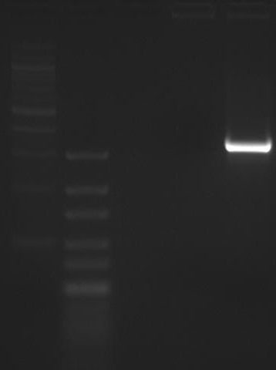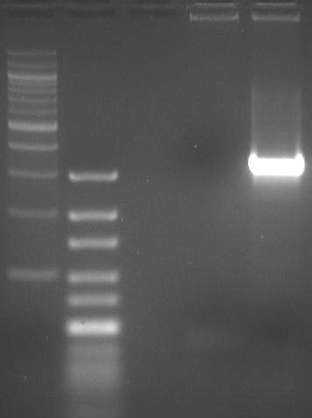
2.5% Agarose Gel 120V ~60min
1— NEB Quick-Load 100bp Ladder
2— Thermo GeneRuler Ultra Low Range DNA Ladder
3— 175bp PCR product 58°C
4— 175bp PCR product 52°C
5— 175bp PCR product 58°C (w/ DMSO)
6— 175bp PCR product 52°C (w/ DMSO)
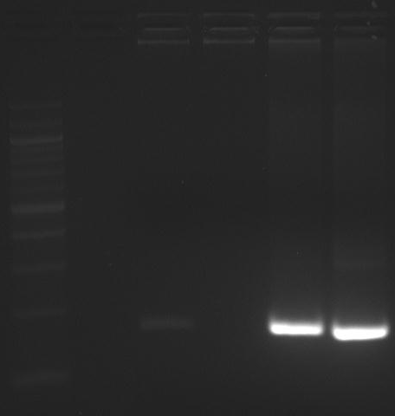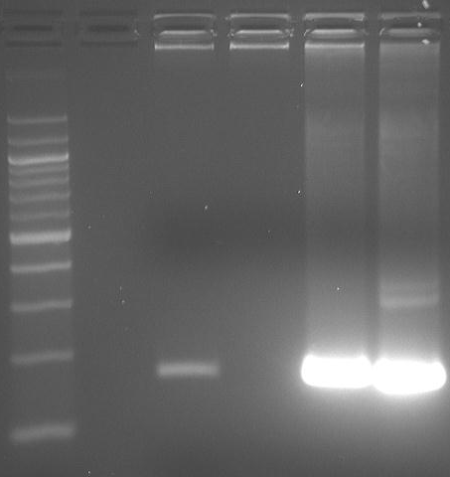
0.65% Agarose Gel 100V ~200min

CONCLUSION:
Clones 5 and 6 were in-frame Quick-Fusion products. Selected both clones for subsequent rxns.
NEXT STEPS:
LB-Amp plate clones 5 and 6, mini-prep and sequence verify sequence, gel purify supercoiled DNA,
update the vector DB, and proceed with the LR Clonase II rxn to swap hTdT for an attR cassette.

